# **Iterative loop of ML Development**

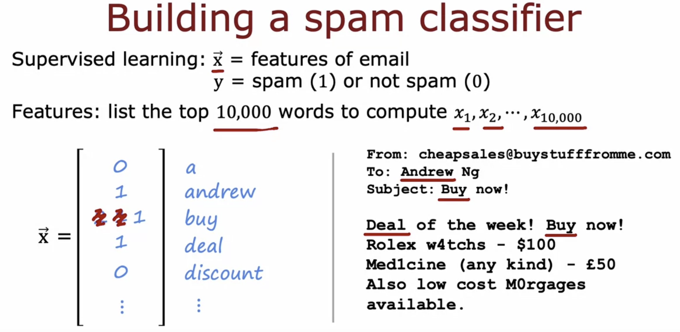

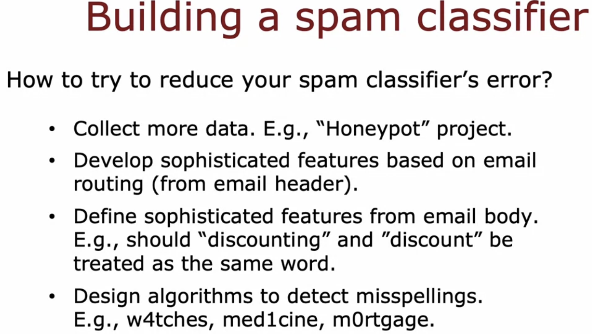

# **Error Analysis**

# **Adding Data**

# **Transfer learning : using data from a different task**

# **Full cycle of a machine learning project**

# **Fairness, bias and ethics**

# **Iterative loop of ML Development**